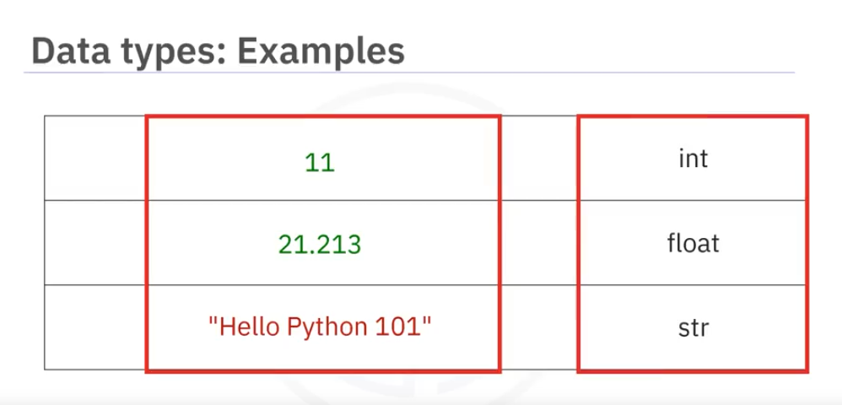

It means that float are also intergers but the values or we can say point values lie between integer can only be counted in float.

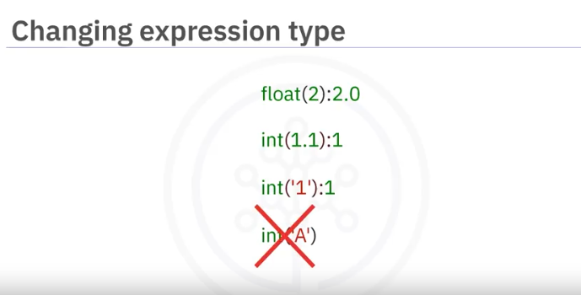

Now the above pic is telling that we can change the types of values into another type known as Type casting. But if we are converting string value **A** to integer So it raise error bcuz **A** is a non-integer value that why it not possible to convert it in number.

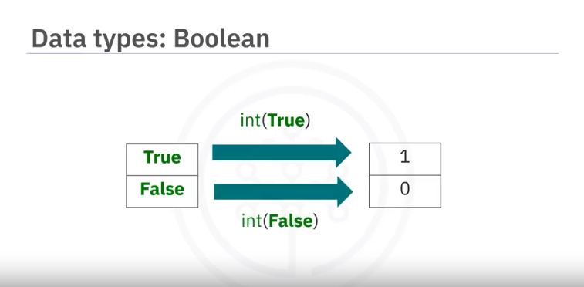

Exercise Ques:

Q-What is the data type of the result of: 6 / 2?

Ans- Float (bcuz when we will do division so return type will be float)

Q- What is the type of the result of: 6 // 2? (Note the double slash //.)

Ans- Integer (bcuz when we put **//** so its mean now after division the return type will be Integer.)

Q-What is the result of the following: **int(3.99**)?

Ans: Its answer is **3** not 4 , bcuz jab typecast kreingay toh it will not roundoff it will just remove the points values and return integer number.